Principles of Communication

Systems Lab

Lab 1, 13th August 2019

Pratyush Nandi (IMT2017518)

Answer to Q1

1(b):

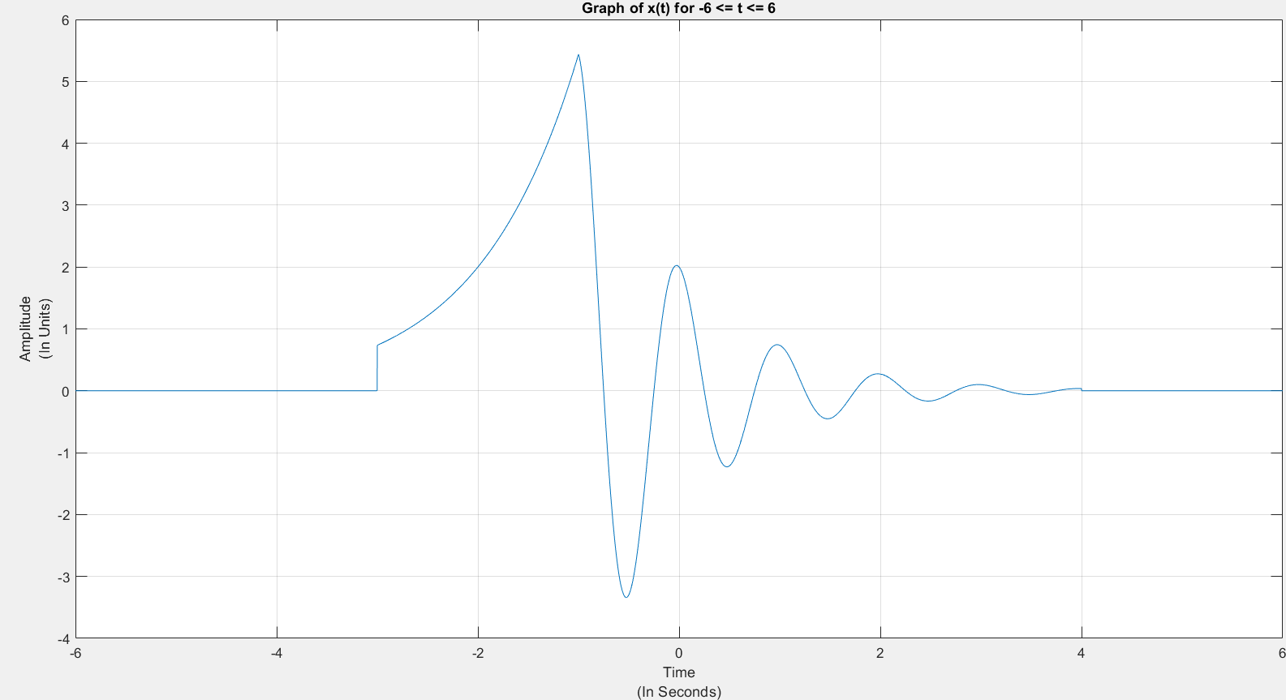

1(c):

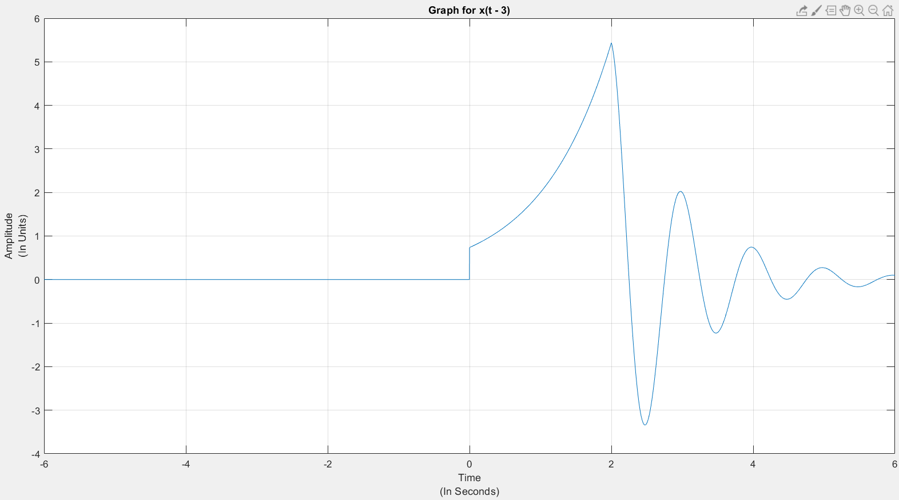

1(d):

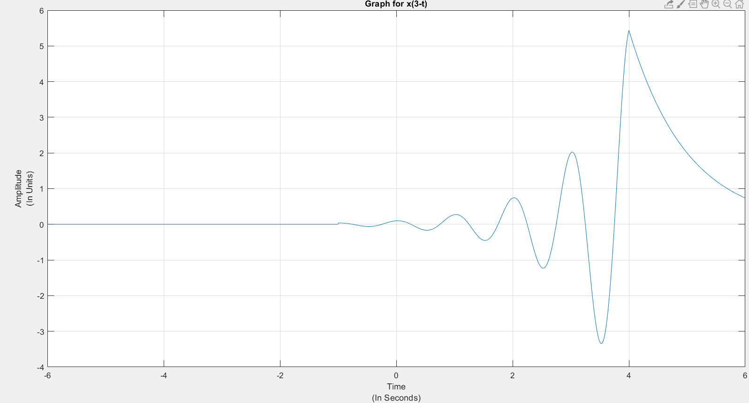

1(e):

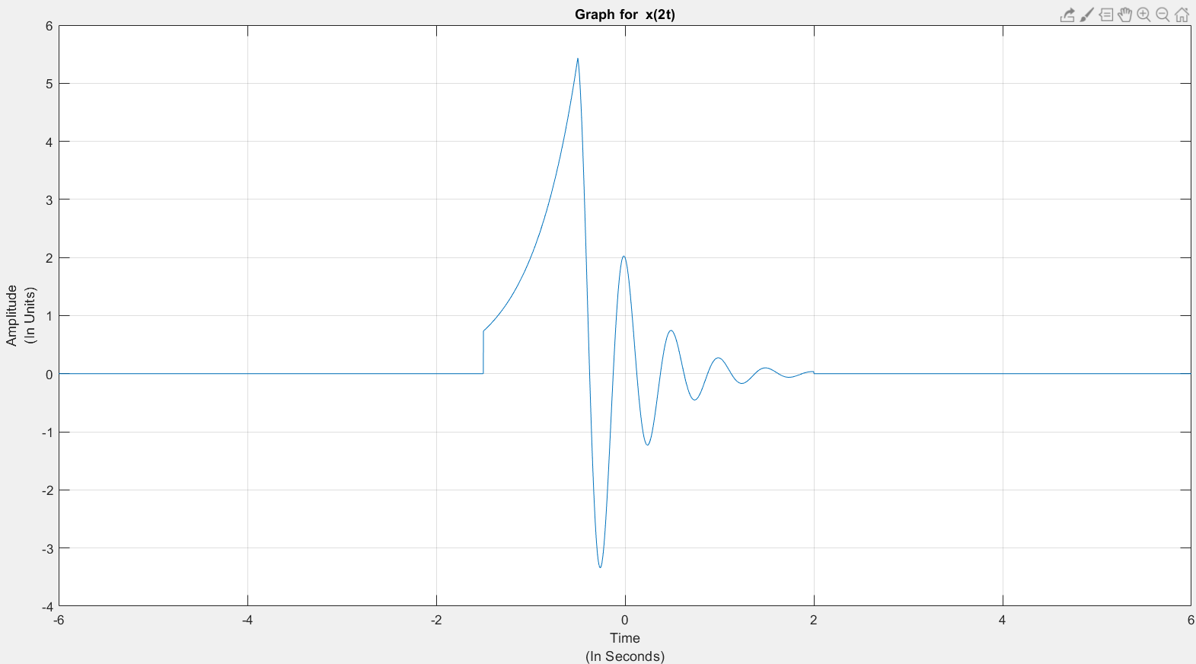

Question 1 Explanation:

In first question part 1 we are forming a signal with given conditions.

In part 2 of first question we are shifting the signal by 3 units on +ve x-axis.

In part 3 we are inverting the signal and shifting it by 3 units on x-axis.

In part 4 we are multiplying the signals time component by 2 basically shrinking the signal in time domain.

Answer to Q2

2(b):

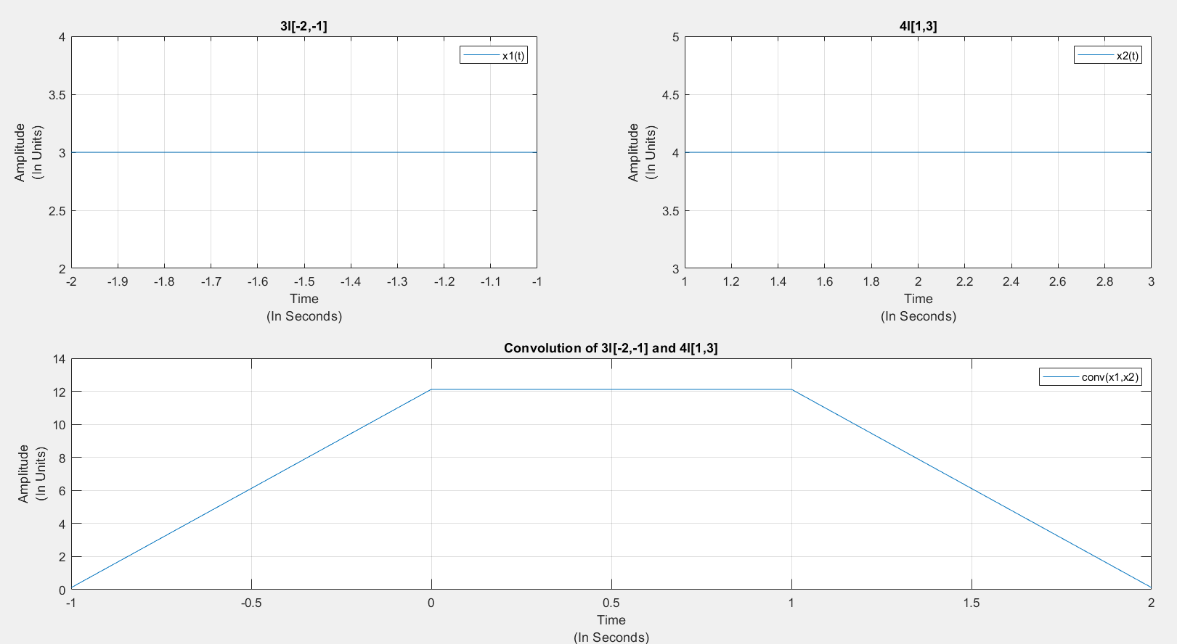

2(c):

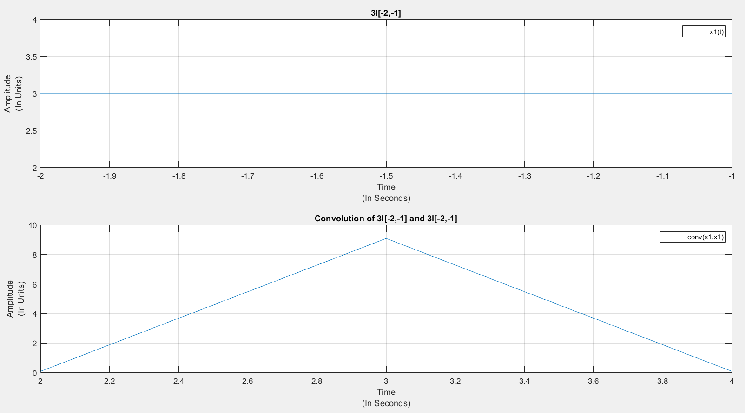

Question 2 Explanation:

In second question part 1 we are convolving the signal x1 ie 3I[-2,-1] indicator function with x2 ie 4I[1,3] and we get a trapezium.

In part 2 of second question we are convolving the signal x1 with itself so we get a triangle.

Appendix:

Code for Question 1:

function plot_one

%Time vector

t = -6:0.001:6;

%Output vector

yb = signalx(t);

yc = signalx(t-3);

yd = signalx(3-t);

ye = signalx(2*t);

%Plot for q1

figure(1);

plot(t,yb);

%set(gca,'XLim',[-7 7])

xlabel({'Time','(In Seconds)'});

ylabel({'Amplitude','(In Units)'});

grid on;

title('Graph of x(t) for -6 <= t <= 6');

figure(2);

plot(t,yc);

%set(gca,'XLim',[-7 7])

xlabel({'Time','(In Seconds)'});

ylabel({'Amplitude','(In Units)'});

grid on;

title('Graph for x(t - 3)');

figure(3);

plot(t,yd);

%set(gca,'XLim',[-7 7])

xlabel({'Time','(In Seconds)'});

ylabel({'Amplitude','(In Units)'});

grid on;

title('Graph for x(3-t)');

figure(4);

plot(t,ye);

%set(gca,'XLim',[-7 7])

xlabel({'Time','(In Seconds)'});

ylabel({'Amplitude','(In Units)'});

grid on;

title('Graph for x(2t)');

end

function s = signalx(t)

s = arrayfun(@arr_signal,t);

end

function x = arr_signal(t)

if(t>=-3 && t<=-1)

x = 2*exp(t+2);

elseif(t>=-1 && t<= 4)

x = 2*exp(-t)*cos(2*pi*t);

else

x = 0;

end

end

Code for Question 2:

function plot_two

dt = 0.01;%sample spacing

s1 = -2:dt:-1; %sampling times over the interval [-2,-1]

s2 = 1:dt:3; %sampling times over the interval [1,3]

x1 = 3*ones(length(s1),1); %samples for first box

x2 = 4*ones(length(s2),1); %samples for second box

[y,t] = contconv(x1,x2,s1(1),s2(1),dt);

[y1,t1] = contconv(x1,x1,s2(1),s2(1),dt);

figure(1);

subplot(2,2,[3,4]);plot(t,y);xlabel({'Time','(In Seconds)'});ylabel({'Amplitude','(In Units)'});

title('Convolution of 3I[-2,-1] and 4I[1,3]');

legend('conv(x1,x2)');

grid on;

subplot(2,2,1);plot(s1,x1);xlabel({'Time','(In Seconds)'});ylabel({'Amplitude','(In Units)'});

title('3I[-2,-1]');

grid on;

legend('x1(t)');

subplot(2,2,2);plot(s2,x2);xlabel({'Time','(In Seconds)'});ylabel({'Amplitude','(In Units)'});

title('4I[1,3]');

grid on;

legend('x2(t)');

figure(2);

subplot(2,1,2);plot(t1,y1);xlabel({'Time','(In Seconds)'});ylabel({'Amplitude','(In Units)'});

title('Convolution of 3I[-2,-1] and 3I[-2,-1]');

grid on;

legend('conv(x1,x1)');

subplot(2,1,1);plot(s1,x1);xlabel({'Time','(In Seconds)'});ylabel({'Amplitude','(In Units)'});

title('3I[-2,-1]');

grid on;

legend('x1(t)');

end

function [y,t] = contconv(x1,x2,s1,s2,dt)

y = conv(x1,x2)*dt;

s1_2 = s1 + (length(x1)-1)*dt;

s2_2 = s2 + (length(x2)-1)*dt;

t1 = s1+ s2;

t2 = s2_2 + s1_2;

t = t1:dt:t2;

end